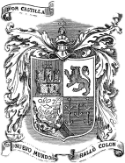
Personal Coat of Arms
What are some importance places for you? What symbols represent these places?

What are your favorite hobbies/activities? What symbols represent these activities?

What is an animal/animals that represent you? Why did you choose those?

What else is important to you and should be represented in your Coat of Arms? What color best represents you?

Ideas for a personal motto?

