Han Dynasty
Map Activity
25pts

Name:___________________________
Period: _________

Use the map to answer the questions.

1. What is the title of the map?________________________________________________
2. What does the map aim to convey?____________________________________________
3. Evaluate the map below then check the boxes (or highlight in red) that apply to the map….
❑ shows political boundaries. ❑ shows land and water features. ❑ has a key. ❑ has a scale.
❑ includes a compass rose. ❑ has grid lines. ❑ has lines of latitude and longitude.
❑ shows individual towns or cities.
❑ includes information specific to the people who live there such as the kinds of business conducted, level of education, or locations of conflict.
4. What hemisphere(s) are shown in part or full on the map?___________________________
5. Use what you know about latitude and longitude to estimate the following: This map spans from ____________ to ___________ latitude and from ____________ to ____________ longitude.
6. What is the scale of this map? (Estimate)
7. List some of the land features that are labeled on the map.
8. List four water features that are labeled on the map.
9. Which body of water appears to cover the greatest area?
10. Describe the key. What symbols are shown? How do they help you understand the information on the map?

11. If you traveled west along the southern line of the Silk Road, you probably went north of these mountains and south of this desert. Name the mountain range and desert.
12. Which city is shown along the Yangtze River?
13. Which city is at approximately 40°N and 94°E?
14. Draw the symbol for the Great Wall of China here.
15. What is the approximate location in latitude and longitude of Kashgar?
16. Given the methods of transportation available at the time, why is it unlikely that many, if any, people ever traveled the entire length of the Silk Road?
17. Which city is almost directly west of Luoyang?
18. Which city appears to be closer to Jade Gate: Chang’an or Kashgar?
19. What is the approximate distance from Guangzhou to Jiangling?
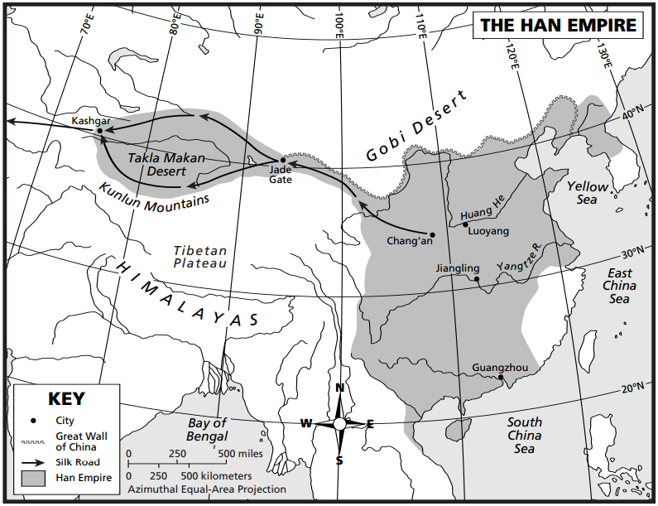
20. What does the gray area represent?

